**MSBA 503 Take Home Assignment**

Word Document

Griffin Synnott

12/8/2024

Analysis: YOLO and Faster RCNN

**Comparison Table (ii):**

The table compares YOLO and Faster R-CNN across 10 images, measuring object detection count, average probability, and analysis time. Faster R-CNN consistently detects more objects with higher confidence (e.g., Food Court: 29 vs. 26 objects, Avg. Probability: 0.85 vs. 0.51) but takes significantly longer to process.

**Other Form of Analysis (ii):**

Extracting dominant colors for: Grocery Store

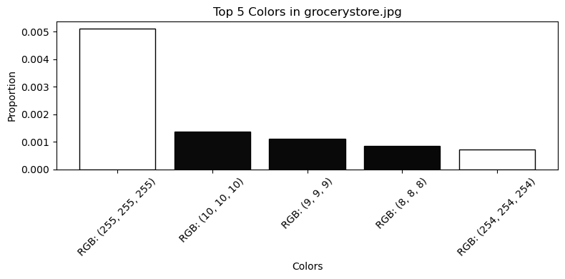

Top Colors for Grocery Store: [(255, 255, 255), (10, 10, 10), (9, 9, 9), (8, 8, 8), (254, 254, 254)]

The chart shows that white (RGB: 255, 255, 255) is the most dominant color in the grocery store image, followed by various shades of dark gray and black (e.g., RGB: 10, 10, 10). This suggests the image contains a significant amount of bright and neutral tones, likely from shelving, packaging, or lighting, with darker elements representing shadows or structural details.



**Work Cited:** [**https://chatgpt.com/**](https://chatgpt.com/)

*OpenAI. ChatGPT. Retrieved and utilized for generating Python code and explanations related to object detection and table visualization enhancements, including YOLO and Faster R-CNN implementations, December 2024.*